|  |  |
| --- | --- |
| Assignment 2 Hadoop  ITRI 623 | ENRICO DREYER  31210783 |

Table of Contents

Introduction 2

Proof 3

My Random notes of the course: 3

Practical: 4

References 4

# Introduction

For this assignment we were asked to make a video of no longer than 2 minutes on any two sections of the Hadoop Udemy Course. For the second Assignment I decided to go with using relational data stores with Hadoop.

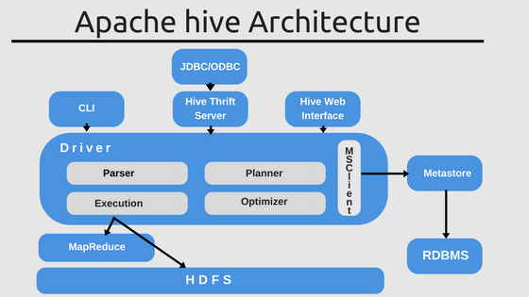

Figure : Hive architecture (Malhotra, 2018)

The following section of the document will discuss the notes of my video

# Proof

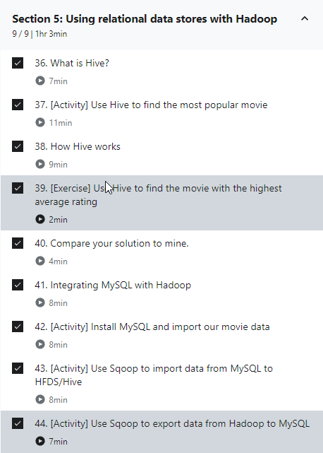

# My Random notes of the course:

**What is Hive?** - Hive is a data warehouse infrastructure tool to process structured data in Hadoop. It resides on top of Hadoop to summarize Big Data and makes querying and analyzing easy (IBM, 2021).

**OLAP Queries** - Online analytical processing (OLAP) is a system for performing multi-dimensional analysis at high speeds on large volumes of data (Galaktikasoft, 2021).

Three kinds of OLAP types: ROLAP, MOLAP, HOLAP

You can upload your data via CSV!

**Example query from course:**

create view topmovieId's AS

select movieId, count(movieID) as ratingCount

From ratings

Group By movieID

Order By ratingCount Desc;

**Google examples:**

# 

Figure : OLAP Examples (slideshare, 2013)

**Apache Sqoop -** Apache Sqoop is a command-line interface application used for transferring data between relational databases and Hadoop (IntelliPaat, 2021).

# References

Galaktikasoft. (2021). OLAP and query language: How to write OLAP queries. <https://galaktika-soft.com/blog/olap-essence-query-language.html>

IBM. (2021). What is Apache Hive? <https://www.ibm.com/analytics/hadoop/hive>

IntelliPaat. (2021). What Is Apache Sqoop? <https://intellipaat.com/blog/what-is-apache-sqoop/#:~:text=Sqoop%20lets%20you%20automate%20the%20process%2C%20and%20depending,and%20exporting%20data%2C%20providing%20a%20parallel%20fault-tolerant%20mechanism>.

Malhotra, A. (2018). Apache Hive – A Faster and Better SQL on Hadoop. <https://www.whizlabs.com/blog/apache-hive-faster-better-sql-on-hadoop/>

slideshare. (2013). OLAP 101 – Queries example. <https://www.slideshare.net/clehene/realtime-olap-for-big-data-use-cases-bigdataro-2013/6-OLAP_101_Queries_example_Rolling>